Practical no. 25
Name :- Danish Altaf Solkar Enrolment no. :-24111590805
Class :- CO3K – B Subject :- DMS
Aim:- Create Functions for given database

Program :-
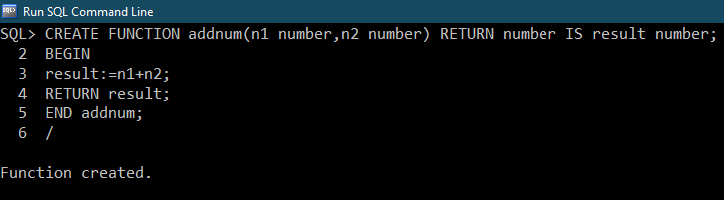
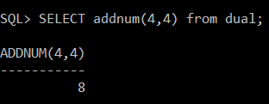

Program :-
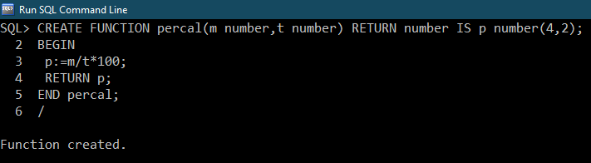
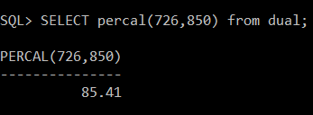

Exercise :-
Program :-
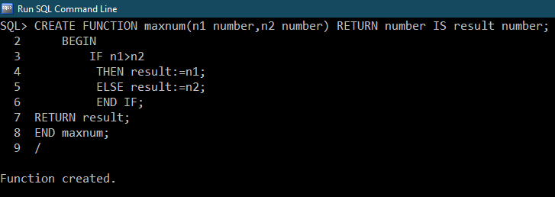
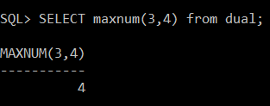

Program :-
